**Soil Layers Lab**

Written by Skylee Shaffer, Education Specialist (2021)

**Purpose of the Lab:**

Oftentimes when soil layers are taught, students understand that soil is made of different layers, and then that is where the learning ends. This activity goes further to show that soil layers vary by region, that not all soil layers are divided equally, and that soil (based on type) can be used for different things. This activity aims to show students that soil is a resource and as a resource soil conservation practices should be considered when planning on how to use the soil.

**Teacher Set Up:**

Teacher will create models of different soil types.

There are 12 soil types, Teachers can make all 12 soil types OR choose the following 6 for a wide variety of soil types:

* Mollisols - Plains grasses
* Gelisols - Permafrost
* Histosols - Wetlands
* Aridisols - Deserts
* Oxisols - Amazon Rainforest
* Alfisol - Midwest

**Materials needed:**

* Clear tubes - can use glass candle votives, clear 2 liter/1 liter bottles, or very large graduated cylinders. (NOTE: if you make and store these well, you should be able to reuse them year after year)
* Different types of soils, rocks, sand and clay. You will need to create different color layers
  + Potting soil
  + Different colored clay (pottery clay is fine)
  + Gravel
  + Different colors of sand
  + Fill dirt
  + Dirt from your back yard
  + Dried leaves for humus and O layer
  + Fake plants to put on top
* Printed copies of the Types Of Soils cards found in the Google Slides - Print 2 slides to a page. One set of cards per group
* Printed Map of Soils of United States - 1 per group (on the same slides presentation, print full size)
* Printed Map of Crops United States - 1 per group(on the same slides presentation, print full size)
  + Consider laminating the maps and cards so that students can draw on them with dry erase markers and you can reuse them

**Directions:**

1. Set up Soil Tubes! The image to the right shows an example of soil tubes. BE AWARE: the soil tubes here have even widths of soil horizons. However, in real life the O, A and B horizons vary in depth, while bedrock can be 100’s of meters below the surface. It is recommended to create the soil horizons as close to real life as possible. See the Soil Horizons Cheat Sheet for suggested layer thickness.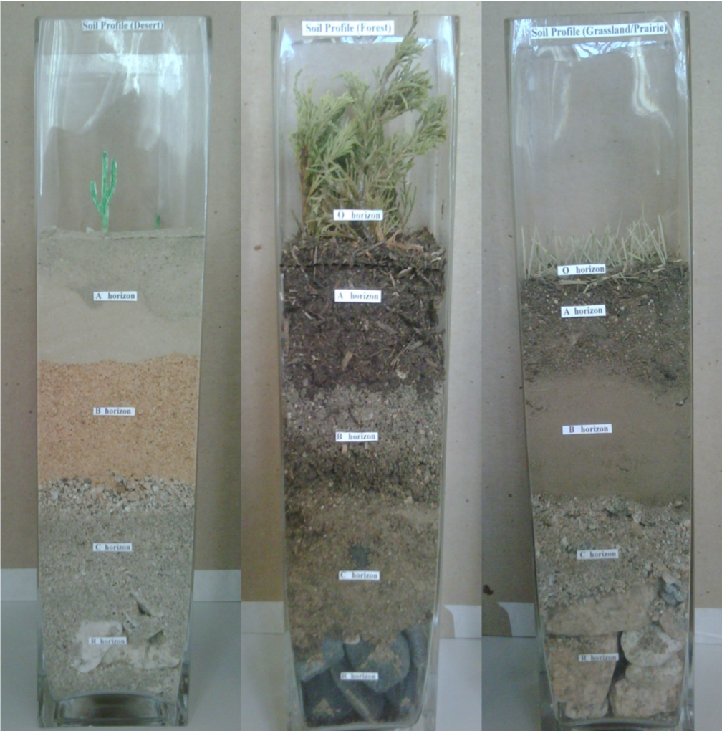
2. Label the Horizons, Label the Tubes with #’s - but do NOT label what type of soil or where this soil is located. That is for the student to find out
3. Have students work on the pre-lab
4. Have students observe the soil tubes in a gallery walk style. Writing down observations in the PreLab section
5. Have students share observations they noticed.
6. Pass out the soil cards - only pass out the cards for the soils you created.
   1. Have students work to identify the soil models based on the information and the cards.
   2. It is important to let students know about Horizon labeling - see link below to understand the soil layer subdivisions
   3. <http://www2.vcdh.virginia.edu/madison/webship/rotorua/horizon.html>
7. Once students have identified the soils, have them answer the questions in part 1 of the Lab.
8. Pass out the Soils of the United States and the Crops of the United States Maps
9. Have students make observations with their groups and discuss as a class some connections they notice - the point is that they see we plant specific crops on specific soils.
10. Have students analyze the maps and answer the questions in part 2 of the Lab.
11. Questions 6 & 7 require Claim, Evidence and Reasoning responses. Students might need to plan with a group. Use these questions as classroom discussion points

**Useful Resources:**

* University of Idaho Soil - <https://www.uidaho.edu/cals/soil-orders>
* Soil Subdivisions - <http://www2.vcdh.virginia.edu/madison/webship/rotorua/horizon.html>
* Mr. Anderson Soil Video - <https://www.youtube.com/watch?v=mg7XSjcnZQM>
* How Soil is created - <https://www.youtube.com/watch?v=vbgM54TXdnk>
* Soils in the Amazon article - <https://www.dw.com/en/the-amazon-nutrient-rich-rainforests-on-useless-soils/a-50139632>

**Constructing Soil Tubes Cheat Sheet**

| Mollisols | Gelisols | Histosols |
| --- | --- | --- |
| Prairie grasses   | O of dead grass | | --- | | A - thick dark topsoil | | B - dark soil - grassroots go way down here | | C | | Bedrock | | Tundra plants   | O - dark | | --- | | Permafrost (Wf)  Use something white to denote ice | | C | | Bedrock | | moss   | O - super dark and wet… make as squishy as possible! | | --- | | C | | Bedrock | |
|  | | |
| Aridisols | Oxisols | Alfisol |
| cactus   | A - super super small -sand | | --- | | B - different color of sand | | C | | Bedrock | | Rainforest trees   | A - light colored clay | | --- | | B - same color as A - use red clay or something to denote there is very little organic matter in the soil | | C | | Bedrock | | Crops or temperate forest   | O - dead crops or leaf litter | | --- | | A - dark and fertile | | E - light gray | | B - some clay | | C | | Bedrock | |

| Andisol - soils made on volcanic ash | Inceptisol | Spodosol - young soil |
| --- | --- | --- |
| grass   | A’ - dark | | --- | | B’ - dark and fertile | | C’ - light gray and ashy | | A - darker than the layers above | | B | | C | | Bedrock | | forest   | A | | --- | | B - with a blend of C | | C - with small rocks | | C with big rocks | | Bedrock | | | O | | --- | | E - gray and ashy | | B | | C | | Bedrock | |
|  | | |
| Ultisol | Vertisol | Entisol |
| Pine forests   | O - dark | | --- | | A - gray and ashy | | E - larger layer - reddish with iron | | B - gray | | C | | Bedrock | | Large cracked dirt   | A | | --- | | B | | C - all layers are of the same material and looked all mixed together | | Bedrock | | | No layers all one type/color of soil | | --- | | C - parent rock material | | Bedrock | |

**Student Lab Sheet**  Name __________________

**Background:**

Soils are an important component of life on Earth. Soils are created over long periods of time through physical, chemical and biological weathering. Soils are technically a renewable resource however, it takes such a long time for soils to regenerate, that improper use of soils can damage this resource for your lifetime. You may go out in your backyard and dig a hole for a tree and notice the different layers of the soil as you dig down. Different soils around the world have different layers. There are 12 different types of soil all made by different processes. The soil in your backyard might be good for planting a tree, a small garden, and even building a shed on top of, but not all soils around the world are well suited for those things. In this lab you will be discovering the different types of soils, where they can be found in the United States and how the soils might be best used in order to conserve this precious resource.

**Essential Question**: How is soil a valuable resource and what are humans doing to change soil quality.

**Student Outcome**: Diagram how matter cycling creates soils and determines the nutrients available. Model soil layers and examine different soil types

**PreLab:**

1. Write down everything you can think of that soil can be used for - feel free to collaborate with your group.
2. From what you remember from the lesson, write down the steps of how soil is formed.
3. What causes soil to have different layers? (O,A,E,B,C and Bedrock)
4. Take a quick glance at the soil tubes created by your teacher, what is the first thing you notice?
5. Why might there be different types of soils?

Observe the soil tubes created by your teacher. In the boxes below draw the soil tubes, with the different layers and make notes of observations of how the soil tubes differ from each other.

| Soil Tube 1 | Soil Tube 2 | Soil Tube 3 |
| --- | --- | --- |
|  |  |  |
| Soil Tube 4 | Soil Tube 5 | Soil Tube 6 |
|  |  |  |

**Part 1: Soil Type Identification**

Now that you have observed the different types of soils, can you correctly match the numbered soil tubes with the Type of Soil described on the cards. Be sure to notice the difference between the model soils and what the soil looks like in real life. Remember models are representations of something that occurs, but may not be exact to the real thing. Use your critical thinking and collaboration skills to match all the cards with the tubes.

1. Write the type of soil under the Soil Tube # - give a **brief** reason why you think the type of soil you chose goes with that tube. Be sure to use evidence.

| Soil Tube 1 | Soil Tube 2 | Soil Tube 3 | Soil Tube 4 | Soil Tube 5 | Soil Tube 6 |
| --- | --- | --- | --- | --- | --- |
|  |  |  |  |  |  |

1. Do some research and find out what each soil type is best suited for: A Google search of “What is [insert soil type here] good for” does the trick.
   1. Mollisols -
   2. Gelisols -
   3. Aridisols -
   4. Histosols -
   5. Oxisols -
   6. Alfisols -
2. Which soil do you think is best for growing corn, what is your evidence?
3. Which soil do you think is best for growing trees for timber, what is your evidence?
4. Which soil do you think is best for storing carbon dioxide, what is your evidence?

**Part 2: Where Are the Soils and What Should We Grow?**

Now that you are familiar with the different types of soils, you can begin to explore where those soils are located and what those soils can be used for.

1. Analyze the Soils of the U.S. Map and the Crops of the U.S. Map. Write down 3 things you notice about the connection of soils and crops.
2. What type of soils are in Indiana and Illinois? What type of crop are they growing?
3. What type of soil is in the southeast United States? What is this soil good for? What are they using it for?
4. Where are the Histosols on the Soil Map? What product is being harvested from there?
5. You may have noticed that in the Southeast United States, what the soil is good for, is not what it is being used for. Where are two other places this is occurring? What is the soil type, what is it good for, and what is it currently being used for?
6. In the lower part of Florida the soil type is Oxisol. This is the same type of soil in the Amazon Rainforest. Currently in the Amazon Rainforest, trees are being cut down, slashed and burned, to make way for agricultural fields. Using Claim, Evidence, and Reasoning - WHY should farmers stop trying to grow crops in the rainforest. Use evidence from the lab and the lesson on soils.
7. The world population is getting bigger and bigger and eventually there will be too many people to feed. Many places like Brazil, in the Amazon Rainforest, are needing to chop down trees in order to feed their people. Design and offer a solution to this problem. How can Brazil make enough food to feed their people and still conserve the soil?