Ocean Acidification Lab - Version 1

* Materials:
  + Beaker
  + Dry Ice
  + Vernier pH probe
  + Lab Quest or Computer Program to display pH data

Procedure:

* Fill the beaker with water
* Take an initial pH reading of the water and record in your data table below

1. What is dry ice?
2. Before you place the dry ice in your beaker, make a prediction below about what you think will happen

* Place the dry ice in the beaker, make sure to keep the pH probe in the beaker at all times.
* Record your data every minute in the following data table

| Minute | pH | Minute | pH |
| --- | --- | --- | --- |
| Minute 0: initial |  | 6 |  |
| 1 |  | 7 |  |
| 2 |  | 8 |  |
| 3 |  | 9 |  |
| 4 |  | 10 |  |
| 5 |  | Difference in pH from initial to 10: | |

1. What is the chemical reaction taking place to make the water acidic?
2. Create a graph from your data

Ocean Acidification Lab - Version 2

* Materials:
  + Bromothymol blue
  + Sandwich baggies
  + Straws

Procedure:

* Fill a small sandwich bag halfway with water
* Add a dropper full of bromothymol blue
  + Bromothymol blue is an acid base indicator. Use the following color key to determine if your water is an acid or a base
  + 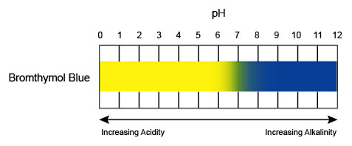

1. What color is the water in your bag?

* Place a straw in the bag with one end sticking out. Seal the bag around the straw
* Blow in the straw for 30 seconds and record any observations below
* Continue to blow in the bag until the water changes to an acid

1. What gas are you blowing into the bag? (What are you exhaling?)
2. What is the chemical reaction taking place to make the water acidic?

Analysis Questions for both versions:

1. What are natural sources of carbon dioxide in the environment?
2. Describe how carbon dioxide gets from the atmosphere into the ocean.
3. Under normal circumstances, the amount of carbon dioxide produced by natural processes is also captured by natural processes. What are some natural carbon sinks (things that capture carbon dioxide from the atmosphere and the ocean).
4. As you learned in the lesson, humans are disrupting the carbon cycle by adding more carbon dioxide to the atmosphere and thereby the oceans. What are some ways that humans are adding carbon dioxide to the system? Be specific.
5. As more and more carbon dioxide ends up in the oceans, what impact will that have on sea life? What impact will that have on the larger food webs? How might this impact humans?